Project Design Phase-II Technology Stack (Architecture & Stack)

|  |  |
| --- | --- |
| Date | 16 October 2022 |
| Team ID | PNT2022TMID40862 |
| Project Name | Emerging Methods for Early Detection of Forest Fire |
| Maximum Marks | 4 Marks |

# Technical Architecture:

The Deliverable shall include the architectural diagram as below and the information as per the table1 & table 2

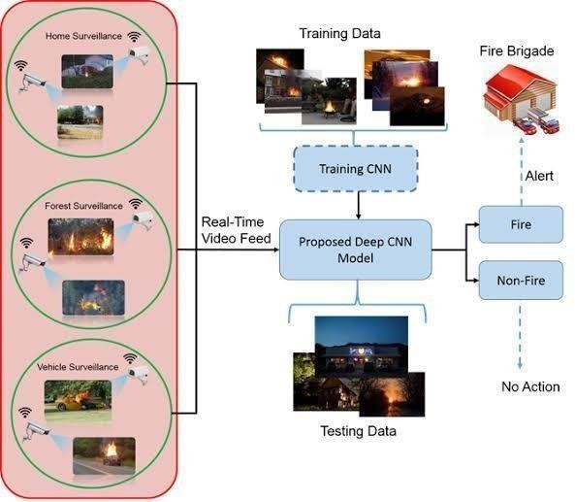

# Table-1 : Components & Technologies:

|  |  |  |  |
| --- | --- | --- | --- |
| **S.No** | **Component** | **Description** | **Technology** |
| **1.** | User Interface (Camera) | How user interacts or see the video feed into the computer | High quality camera |
| **2.** | Camera and Drones | Watching the Forest ; surveillance provided (24*7) all the time | Pan tilt zoom cameras can be used |
| **3.** | Fire System | Identifying smoke by clustering motions with a time input to reduce the number of false alarm | Ura Fire System |
| **4.** | Communication | To send the videos from camera to the system | Network Tower |
| **5.** | Cloud Database | Database Service on Cloud | IBM Cloud |
| **6.** | Application to get the video feed | It gets the image and helps the CNN so check whether fire is present | IBM Watson assistant |
| **7.** | Sensor | Rotates the camera 360 degree every 4 to 6 minutes in a day  OSS at the tower has a wireless connection to the user computer | Optical Sensor can be used |
| **8.** | Image recognizer | It learn and extract complex image features effectively | CNN algorithms can be used |
| **9.** | Detector | It will send an alert sound if the CNN detects the fire | Sound Alarm |
| **10.** | CNN | Gets the image Process it and finds whether fire occurs or not | Four algorithms are used Faster-RCNN , R-FCN , SDD , YOLO V3 |

**Table-2: Application Characteristics:**

|  |  |  |  |
| --- | --- | --- | --- |
| **S.No** | **Characteristics** | **Description** | **Technology** |
| 1. | Open CV | Open – Source Library for image processing | PYTHON PROGRAMING LANGUAGE |